To authorize the transfer of your ODS records from Lincoln College to another institution, please return the completed form to the Office for Disability Services at Lincoln College.

Traditional Program (Lincoln Campus)
Lower Level Harts Science
217.735.7553
ods@lincolncollege.edu
ABE Program (Lincoln, Normal, Oglesby, Peoria)
Academic Building in Normal, Office 106B
309.268.4321
ncods@lincolncollege.edu

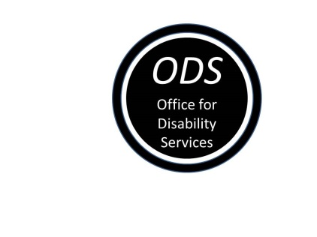
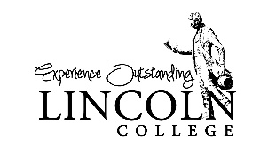
Authorization to Release
Disability Records to Another Institution

I will be attending name of new institution and plan to request academic accommodations.
To facilitate that process, I authorize the release of information about the nature of my disability and specific recommendations related to accommodations I received while a student at Lincoln College.
Please forward a copy of my ODS records to name of Individual or Office.
The information may be (mark as many as apply)
☐ Faxed to fax number of new institution
☐ Emailed as a scanned attachment to email address of approved recipient
☐ Sent through the US mail to street address city state zip

Student Name: Click here to type in your name.
Student ID: Click here to type in your Lincoln College ID number.
Date: Click here to enter a date.

Signature ________________________________________________________

